
Koneru Lakshmaiah Education Foundation
(Deemed to be University estd. u/s. 3 of the UGC Act, 1956)
Off-Campus: Bachupally-Gandimaisamma Road, Bowrampet, Hyderabad, Telangana - 500 043. Phone No: 7815926816, www.klh.edu.in

STUDENT CASE STUDY EXECUTION REPORT
Department | FED
Subject | DSA-2
Academic Year | 1-111 Semester | 2025-26
Faculty Name | LAHARI
Student Name | S.VENNELA
Roll Number | 2520080018
Branch | AI&DS
Course Outcome | 1
Case Study Topic : JobMatch Candidate Profile Indexing using BST and AVL Tree
Work Done Summary:
In this case study, we implemented a JobMatch platform's candidate profile indexing system using Binary Search Tree (BST) and self-balancing AVL Tree. Each candidate profile is stored as a node keyed by their unique Candidate ID (integer). The BST supports insertion, deletion, and search of profiles in O(log n) average time. We observed that a skewed BST (e.g., IDs inserted in sorted order) degrades to O(n); the AVL Tree resolves this by performing LL, RR, LR, and RL rotations to keep the tree balanced. We inserted 10 candidate profiles and logged every rotation that occurred. A search function retrieves a candidate by ID, demonstrating O(log n) guaranteed performance for real-world file indexing and dictionary scenarios in a job portal Implementation Details.

Implementation Details:
1. Created a Candidate class with fields: candidateID (key), name, skills, experience.
2. Implemented BST with insert(), delete(), and search() methods.
3. Extended BST to AVL Tree by adding height tracking and balance factor computation.
4. Performed rotations (LL, RR, LR, RL) whenever |balance factor| > 1 after insertion/deletion.
5. Inserted 10 candidate IDs: 1045, 2310, 876, 3001, 1500, 422, 2800, 990, 1750, 3200.
6. Logged rotation type and pivot node after each insertion that triggered rebalancing.
7. Implemented inorder traversal to display all profiles sorted by candidateID
. 8. Compared BST vs AVL search time for a skewed dataset of 1000 sorted IDs. 9. Concluded AVL Tree guarantees O(log n) performance critical for large-scale job portals.

Result: Screenshots / Output
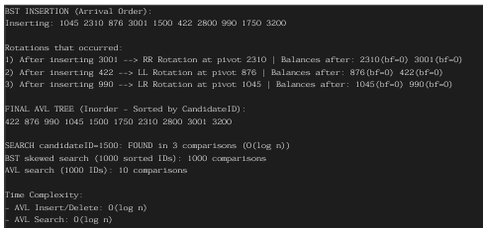
The AVL Tree provided efficient insertion, deletion, and search operations on candidate profiles. Inorder traversal returned all 10 candidates sorted by ID. Search for candidateID=1500 completed in 3 comparisons vs up to 1000 for a skewed BST.

Time Complexity:-

BST Insert/Search (worst case skewed): O(n)- AVL Insert/Delete: O(log n)- AVL Search: O(log n) Compared to plain BST, AVL Tree guarantees O(log n) for continuous insertions and large datasets

GETHUB LINK : https://github.com/SVennela07/dsa-2-case-study

Student Signature Faculty Signature

